**Lab Exercise 6– Terraform Multiple tfvars Files**

**Steps:**

**1. Create a Terraform Directory:**

**mkdir terraform-multiple-tfvars cd terraform-multiple-tfvars**

# # main.tf

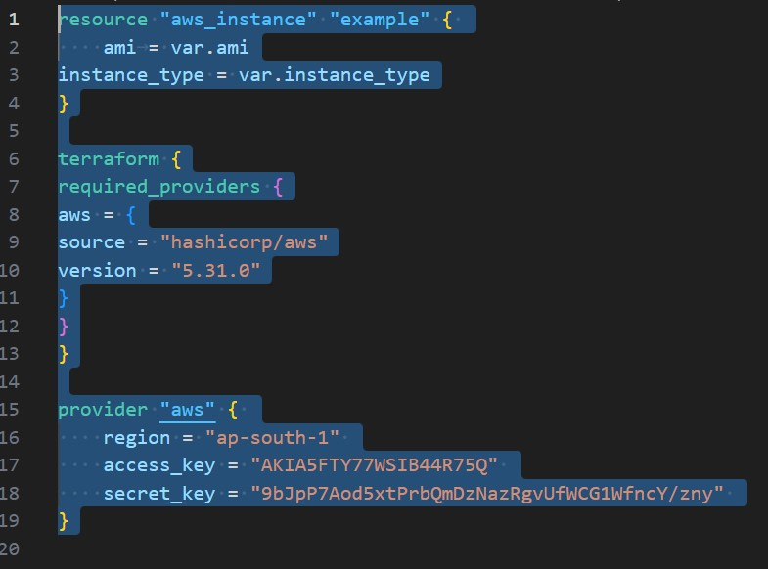**\**

# # variables.tf

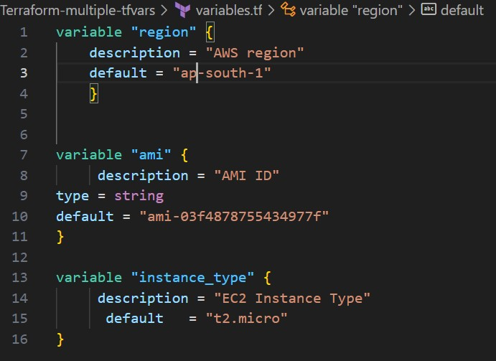

**2. Create Multiple tfvars Files:**

# # dev.tfvars

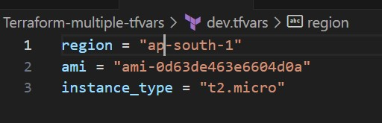

# # ops.tfvars

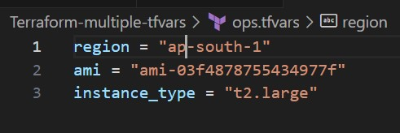

**3. Initialize and Apply for Dev Environment:**

• Run the following Terraform commands to initialize and apply the configuration for the dev environment:

**terraform init**

**terraform apply -var-file=dev.tfvars**

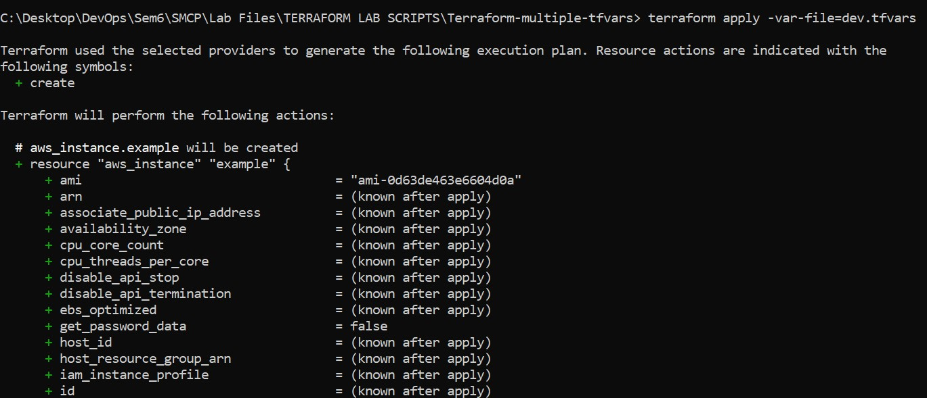

**4. Initialize and Apply for Prod Environment:**

• Run the following Terraform commands to initialize and apply the configuration for the prod environment:

**terraform init**

**terraform apply -var-file=ops.tfvars**

  .

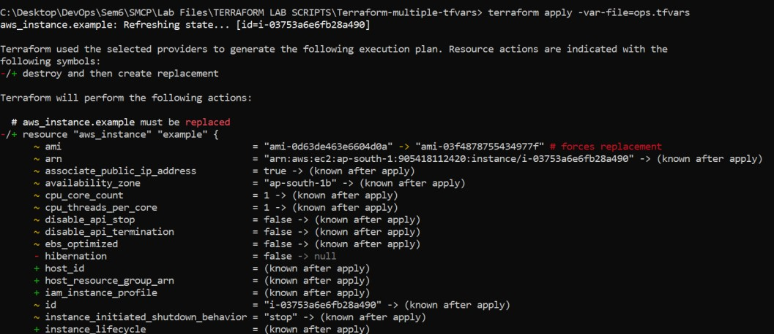

1. **Test and Verify:**

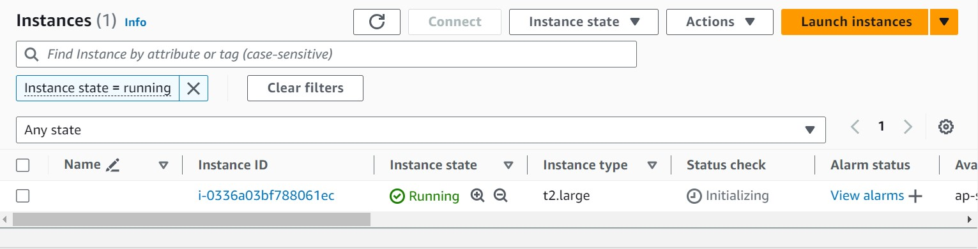

1. **Clean Up:**

**terraform destroy -var-file=dev.tfvars terraform destroy -var-file=ops.tfvars**



  